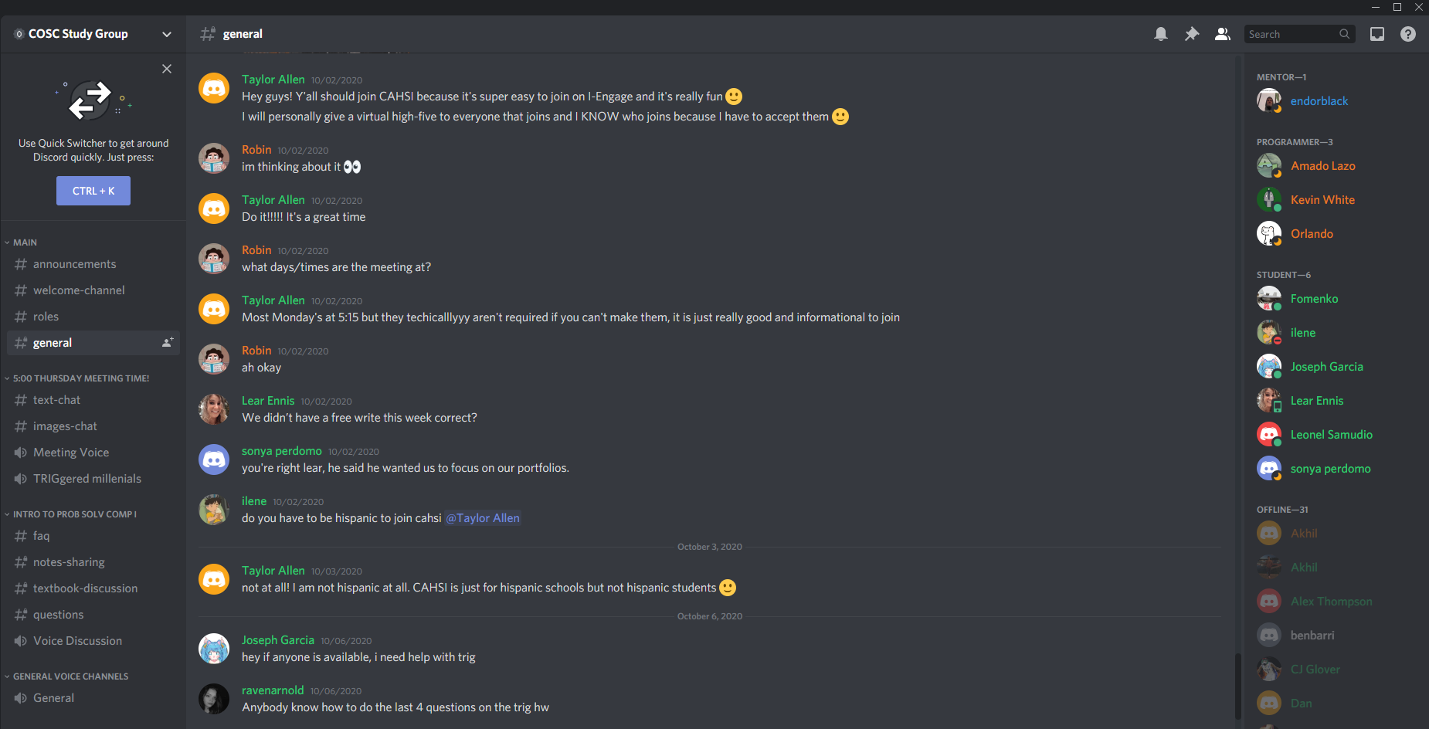

This week a lot of people where having problems with trig and so was I. a few of us helped each other with the homework. Less and less people are showing up in person… and ironically more and more people are having problems. Luckily I have been doing very well and have been able to help a few people in and out of our learning community.